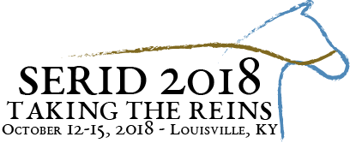
CALL FOR INTERPRETERS
The Southeast Regional Institute on Deafness (SERID), a non-profit organization, is pleased to announce its annual conference to be held at the Hyatt Regency in downtown Louisville, KY from October 12-15, 2018.

The 2018 SERID Conference Committee is currently seeking applications for interpreters for the 2018 SERID Conference.

Requirements for Consideration:
RID/NAD Certification
Previous Conference Experience
Completed Application
Application Process:
Please Include:
Resume
Provide Contact information for three Professional References: preferably at least one Deaf individual

Submit SERID 2018 Interpreter Application Form no later than June 30th 2018.

Applications will be reviewed and candidates will be determined no later than July 30th 2018.

(Formal Interpreting Service Agreement to Follow)
Please submit all documentation via email to Patti Phelps:
PattiG.Phelps@ky.gov

For additional information or questions, please contact:
Amy Holt, Interpreter Coordinator Committee Co-Chair: (270) 282-1186 or Amy.Holt@ky.gov
Patti Phelps, Committee Co-Chair: (502) 352-8039 or PattiG.Phelps@ky.gov

SERID 2018
P.O. Box 899
Frankfort, KY 40602-0899
WWW.SERID.ORG

