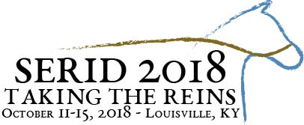

**Southeast Regional Institute on Deafness, Inc.**

**Pre-Conference Choices**

**October 12th, 2018**

**9:00a.m. - 4:30 p.m.**

**Empowerment Through Access: Working with Individuals who are Deaf-Blind**

**Presented By Marilyn C. Trader, MSW & Ashley Benton, LCSW**

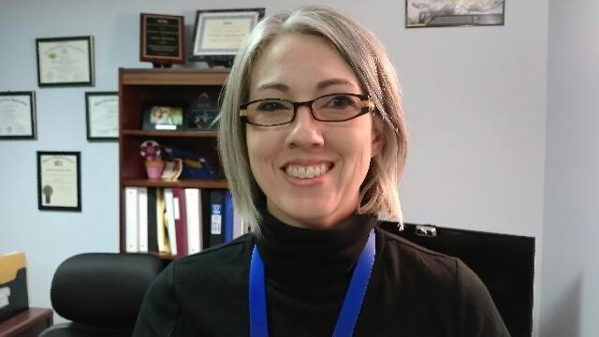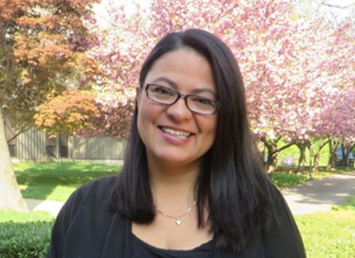

Participants who attend this workshop will gain knowledge and an understanding of the diverse deaf-blind population, the various communication modalities and techniques utilized within the community for successful independence. Having the full access to all the resources available will allow all our consumers successful outcomes if given all the tools to accomplish their goals. This session will not only provide an overview of the culture but will give strategies on how to effectively ensure equal access is given for individuals who have a combined vision and hearing loss working within various agencies.

Learning Objectives:

* Participants will have a basic understanding of the diversity within the Deaf-Blind Community
* Participants will have a clear understanding of SSP/Interpreter roles, responsibilities, and expectations.
* Participants will learn about a variety of communication modalities used in within the Deaf-Blind Community.
* Participants will be able to have access to national and state resources.

**Communication Skills Assessment Training**

**Presented By Roger Williams LMSW, ABD, CT/NAD 5 and Charlene Crump, BS, CI/CT, QMHI-S, CRCC-passed**

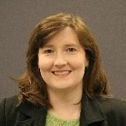

The Communication Skills Assessment Training will focus on an overview of communication assessment and language dysfluency within the Deaf population. Understanding a consumer's best language through language assessment allows service providers across multiple disciplines to work collaboratively. Deaf persons with language dysfluency and communication disorders are present in almost all settings. A demonstration and discussion on the use of the communication skills assessment tool including case study review will be included.

Learning Objectives:

* Identify reasons related to the need for communication assessments.
* List and identify causes of language dysfluency
* Discuss implications for language dysfluency in service provision
* Complete a communication assessment on sample videos
* Discuss use of communication assessments within various service agencies

**ASL Interpreters and CART Provided for Both Sessions**

**To Register:**

[**https://serid.org/conference/registration/**](https://serid.org/conference/registration/)

**Don’t Miss the Early Bird Deadline of July 31st for Savings!**