Preconference Track: Full Steam Ahead for Accessible Video
October 10th, 2019
10:00am – 4:30pm

Those who work in the field of disabilities know that captioning is an important part of making every video accessible. However, not everyone understands the captioning process or captioning standards. Captioning is more than just adding spoken dialogue. It includes sound effects, speaker identification, music description, and much more. It is important that the captions are (1) synchronized and appear at approximately the same time as the audio is delivered; (2) equivalent and equal in content to that of the audio, including speaker identification and sound effects; and (3) accessible and readily available to those who need or want them.

This presentation will look at the captioning standards. Participants will use the DCMP Captioning Key to evaluate a variety of captioned clips. They will learn what standards are essential for readability and why low quality captions are worse than no captions. They will learn what caption formatting is available with different software and platforms.

This presentation will provide a hands on experience of how to add captions to a video.
Participants will learn the captioning process, then practice each step. They will be exposed to a variety of captioning programs and learn the pros and cons of each.

Participants will leave with an understanding of captioning standards, the process, and basic techniques. They will be able to evaluate the quality of captions and choose an appropriate captioning method for their individual and/or organizational needs.

Learning objectives
Participants will be able to:
- Describe the importance of captions and who they benefit
- Identify components of quality captions
- Experience key steps in the captioning process
- Compare different approaches to providing captions

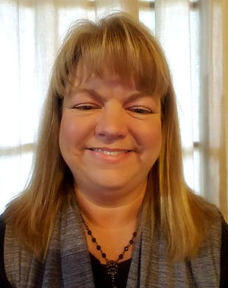

Cindy Camp, Marketing and Communications Specialist, MA, Nationally Certified Interpreter, Mental Health Certified Interpreter

