Preconference Track: STEM-finity Wars
October 10, 2019
10:00am - 4:30pm

The jobs of the future are in Science, Technology, Engineering, and Math (STEM). These jobs will be in high demand and the best paying jobs. STEAM is an educational approach to learning that uses Science, Technology, Engineering, the Arts and Mathematics as access points for guiding student inquiry, dialogue, and critical thinking. The end results are students who take thoughtful risks, engage in experiential learning, persist in problem-solving, embrace collaboration, and work through the creative process. These are the innovators, educators, leaders, and learners of the 21st century.

STEM Wars is a program developed in Alabama to expose students who are deaf, hard of hearing, blind and low vision to high-tech and low-tech jobs of the future. This interactive presentation will teach you how to conduct your own STEM based activities with students or adult learners. Participants will get an overview of STEM careers ranging from those that require college degrees to those that only require a high school diploma. Participants will divide into teams and compete in a variety of STEM based challenges in areas like cyber security, robotics, welding, and coding.

What are the Objectives of STEM Wars?
- Promote interest in STEM Careers
- Allow for mentorship experience with STEM professionals
- Learn practical principles of cyber safety and cyber security
- Provide hands-on STEM activities
- Practice critical thinking
- Engage in peer interaction
- Build teamwork experience
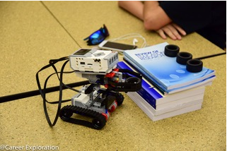
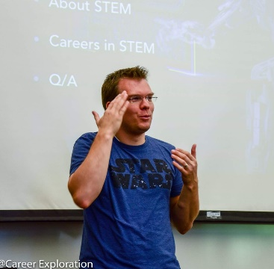
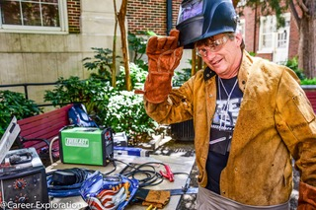
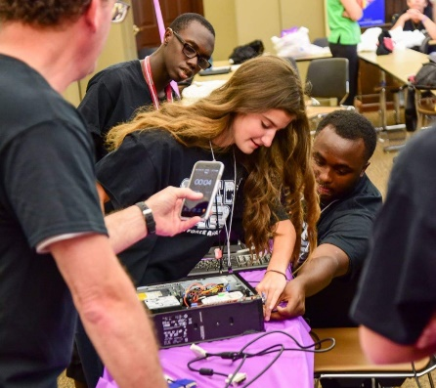
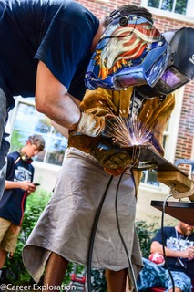
- Promote STEM resources and events

