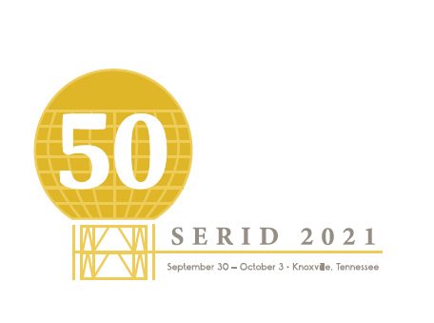
CALL FOR VOLUNTEERS
Invitation: The 2021 Southeast Regional Institute on Deafness (SERID) will be held at the Hilton Downtown Knoxville in Knoxville, TN September 30- October 3. SERID focuses on the educational and professional development of individuals who work with consumers who are Deaf, Deaf Blind, Hard of Hearing, and late- deafened. The conference is designed to allow participants to explore cutting-edge principles, strategies, and tools that will enable them to provide accessible services to those they serve. SERID will consist of concurrent sessions, plenary sessions, pre-conference workshops, and exhibits.
REQUIREMENTS FOR VOLUNTEERS:
- Completed applications must be submitted by September 1, 2021
- Volunteers must be age 18 and older
Please send Completed Application (next page) to:
Tiffany Kelley
info@serid.org
OR
P.O. Box 3
Knoxville, TN 37901

VOLUNTEER APPLICATION
Please complete the following:
Name:

Address:

City: | State: |  | Zip:
Email:

Phone: Voice/Text |  | VP:

Describe your ASL Proficiency level
Please indicate where you would be most interested in working:
Registration Table
Conference set up/take down
Runner/Assistant to Planning Team
Workshop/Session Moderator
Please indicate your availability:
Wednesday, September 29 (Set Up)
Thursday, September 30
Friday, October 1
Saturday, October 2
Sunday, October 3

