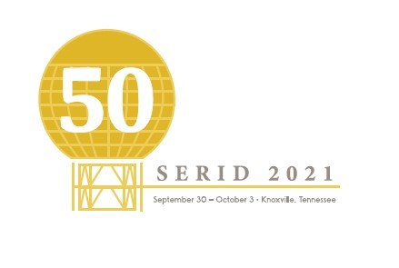
Award Nominations
SERID is seeking nominations for individuals deserving of the below awards. These awards will be presented at the SERID 2021 Conference in Knoxville, TN during the Awards banquet held on Saturday, October 2, 2021.
William E. Woodrick Case of the Year Award
Presented to a rehabilitation provider in recognition of unique and/or outstanding efforts in the rehabilitation of a Deaf or Hard of Hearing individuals resulting in successful competitive employment.
Distinguished Service Award
Presented to an individual who has demonstrated outstanding community leadership, personal achievement, or contributions to individuals who are Deaf or Hard of Hearing.
Outstanding Deaf or Hard of Hearing Individual Award
Presented to a Deaf or Hard of Hearing individual who has exhibited outstanding leadership with the Deaf or Hard of Hearing community.
Outstanding Educator of the Year Award
Presented to an individual who exemplifies the highest standard of the teaching profession and who demonstrates extraordinary commitment to the educational excellence, learning, and welfare of Deaf or Hard of Hearing students.
Marie Griffin Interpreter of the Year Award
Presented to an individual who has demonstrated outstanding community leadership, personal achievement, or contributions to individuals who are Deaf or Hard of Hearing.
Employer of the Year Award
Presented to a business who has shown a commitment to the employment of Deaf or Hard of Hearing individuals.

Nominations for these awards must be submitted by August 20, 2021 via e-mail to info@serid.org. Please include “Award Nomination” in the subject line of the email.
Nomination letters should include a 150-word biography of the nominee and a 250-500 word letter explaining the attributes of the nominee and reasons for nomination. Letters of support are also welcome and should be included with the actual nomination letter.

