Dear Sponsor,

The Southeast Regional Institute on Deafness (SERID), a non-profit organization, is celebrating the 50th Anniversary! Our annual conference is committed to providing the most relevant and effective training for professionals working with the Deaf, DeafBlind, and Hard of Hearing communities. We are pleased to announce this monumental event will be held at the Hilton located in Downtown Knoxville, Tennessee from September 30 – October 3, 2021.

SERID is a unique training opportunity that focuses on service delivery to individuals who are Deaf, DeafBlind, and Hard of Hearing within these areas: State Rehabilitation Services, Education, Mental Health, Transition, Interpreting, and more. The annual conference promotes and improves collaboration between service providers and communities serving these consumers within the southeast region and beyond.

We continuously work with our regional and national partners to discover new ways to address challenges in service delivery. You can help by supporting our conference initiatives in the following ways:

• Become a corporate sponsor
• Host an event
• Become an exhibitor
• Purchase a program book advertisement
• Donate items for the silent auction
• Make a tax-deductible donation of any amount to SERID.

We anticipate attracting 300+ registered participants. All contributions can be claimed as a tax-deductible expense to a non-profit organization by using SERID TIN: 01-0554310.

For additional information about the conference, please visit www.serid.org. Please send an email to info@serid.org if you have any questions.

We thank you in advance for your sponsorship and support. Your investment in the 2021 Southeast Regional Institute on Deafness conference will allow you to showcase your products and services, as well as serve as an inspiration to our community. Your support will make this conference especially memorable for all attendees. We hope that you will be a part of this exciting event through one of our numerous sponsorship opportunities.

Warmly,
Tiffany Kelley
Tiffany Kelley
2021 Tennessee Conference Chair

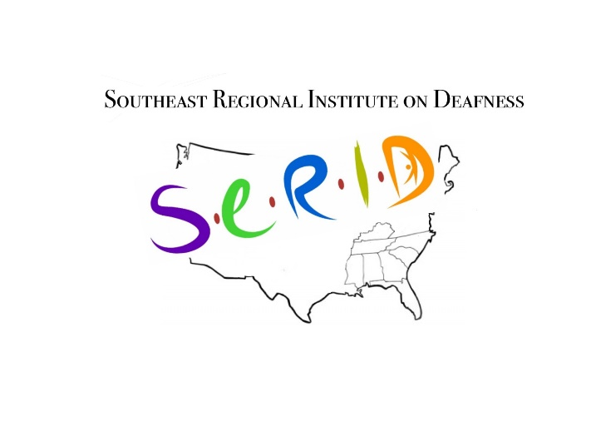

Diamond
$12,500

Platinum
$10,000

Gold
$7,500

Silver
$5,000

Bronze $2,500

Other/In Kind

The Diamond level sponsor will receive recognition as a conference partner during the conference and related events. This sponsor will have a complimentary full-page advertisement of their company logo printed in the program book. This level of sponsorship also includes: One exhibit space during the entire conference; Two 10-minute opportunities to address conference attendees during general sessions; Two full conference registrations.

The Platinum level sponsor will receive recognition as a conference partner during the conference and related events. This sponsor will have a complimentary ½-page advertisement of their company logo printed in the program book. This level of sponsorship also includes: One exhibit space during the entire conference; One 5-minute opportunity to address conference attendees during a general session; One full conference registration.

The Gold level sponsor will receive recognition during the conference and related events. This sponsor will have a complimentary ¼-page advertisement of their company logo printed in the program book. This level of sponsorship also includes: One exhibit space during the entire conference and one 5-minute opportunity to address conference attendees during a general session.

The Silver level sponsor will receive recognition during the conference and related events. This sponsor will have a ¼-page advertisement of their company logo printed in the program book. Includes: One exhibit space during the entire conference.

The Bronze level sponsor will receive recognition during the conference and related events. This sponsor will have a business card size advertisement of their company logo printed in the program book. Includes: One exhibit space during the entire conference.

Agencies, businesses, and individuals are welcome to make an in-kind monetary or product donation. Donated items such as Deaf-made art, gift certificates, and gift baskets will be entered in the Silent Auction. Silent Auction proceeds will be used to fund future SERID conferences.
SPONSORSHIP FORM

Organization Name

Point of Contact

Street Address City State Zip Code

Phone Fax E-mail Website

LEVEL OF SPONSORSHIP

_____ $12,500 Diamond Sponsor (Exhibit space and full-page advertisement included)
_____ $10,000 Platinum Sponsor (Exhibit space and half-page advertisement included)
_____ $7,500 Gold Sponsor (Exhibit space and quarter-page advertisement included)
_____ $5,000 Silver Sponsor (Exhibit space and quarter-page advertisement included)
_____ $2,500 Bronze Sponsor (Exhibit space and business card advertisement included)
_____ Other/In-Kind Sponsor

Payment are expected in full by May 15, 2021. Please complete and send sponsorship form with your payment (check or money order) to:
SERID, Inc.
Attention: Jessica Villanueva
P.O. Box 3
Knoxville, TN 37901

Monetary Sponsorship $__________

AGREEMENT

The undersigned agrees to abide by SERID monetary, hosting, exhibiting, and program book sponsorship rules and regulations.

Signature Title Date

Event Name: | Southeast Regional Institute on Deafness 2021

Organization Name: | Southeast Regional Institute on Deafness (SERID, INC.)

Event Dates: | Thursday, September 30, 2021 - Sunday, October 3, 2021

