Dear Sponsor,

The Southeast Regional Institute on Deafness (SERID), a non-profit organization, is celebrating the 50th Anniversary! Our annual conference is committed to providing the most relevant and effective training for professionals working with the Deaf, DeafBlind, and Hard of Hearing communities. We are pleased to announce this monumental event will be held at the Hilton located in Downtown Knoxville, Tennessee from September 30 – October 3, 2021.

SERID is a unique training opportunity that focuses on service delivery to individuals who are Deaf, DeafBlind, and Hard of Hearing within these areas: State Rehabilitation Services, Education, Mental Health, Transition, Interpreting, and more. The annual conference promotes and improves collaboration between service providers and communities serving these consumers within the southeast region and beyond.

We continuously work with our regional and national partners to discover new ways to address challenges in service delivery. You can help by supporting our conference initiatives in the following ways:

• Become a corporate sponsor
• Host an event
• Become an exhibitor
• Purchase a program book advertisement
• Donate items for the silent auction
• Make a tax-deductible donation of any amount to SERID.

We anticipate attracting 300+ registered participants. All contributions can be claimed as a tax-deductible expense to a non-profit organization by using SERID TIN: 01-0554310.

For additional information about the conference, please visit www.serid.org. Please send an email to info@serid.org if you have any questions.

We thank you in advance for your sponsorship and support. Your investment in the 2021 Southeast Regional Institute on Deafness conference will allow you to showcase your products and services, as well as serve as an inspiration to our community. Your support will make this conference especially memorable for all attendees. We hope that you will be a part of this exciting event through one of our numerous sponsorship opportunities.

Warmly,
Tiffany Kelley
Tiffany Kelley
2021 Tennessee Conference Chair

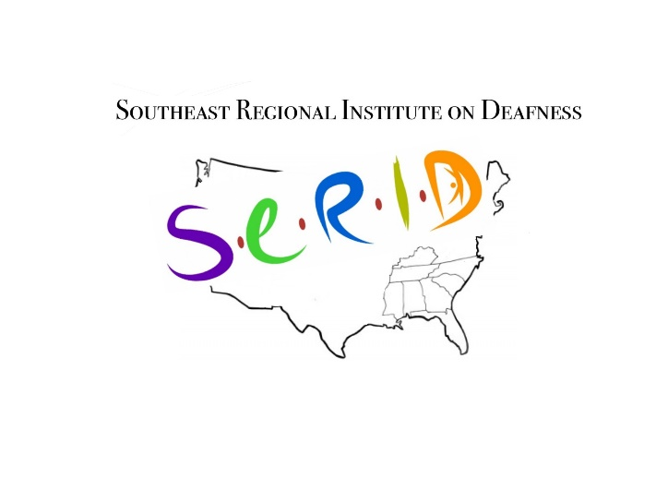

Sponsorship Levels
Diamond
$12,500

Platinum
$10,000

Gold
$7,500

Silver
$5,000

Bronze $2,500

Other/In Kind

The Diamond level sponsor will receive recognition as a conference partner during the conference and related events. This sponsor will have a complimentary full-page advertisement of their company logo printed in the program book. This level of sponsorship also includes: One exhibit space during the entire conference; Two 10-minute opportunities to address conference attendees during general sessions; Two full conference registrations.

The Platinum level sponsor will receive recognition as a conference partner during the conference and related events. This sponsor will have a complimentary ½-page advertisement of their company logo printed in the program book. This level of sponsorship also includes: One exhibit space during the entire conference; One 5-minute opportunity to address conference attendees during a general session; One full conference registration.

The Gold level sponsor will receive recognition during the conference and related events. This sponsor will have a complimentary ¼-page advertisement of their company logo printed in the program book. This level of sponsorship also includes: One exhibit space during the entire conference and one 5-minute opportunity to address conference attendees during a general session.

The Silver level sponsor will receive recognition during the conference and related events. This sponsor will have a ¼-page advertisement of their company logo printed in the program book. Includes: One exhibit space during the entire conference.

The Bronze level sponsor will receive recognition during the conference and related events. This sponsor will have a business card size advertisement of their company logo printed in the program book. Includes: One exhibit space during the entire conference.

Agencies, businesses, and individuals are welcome to make an in-kind monetary or product donation. Donated items such as Deaf-made art, gift certificates, and gift baskets will be entered in the Silent Auction. Silent Auction proceeds will be used to fund future SERID conferences.

Exhibitor Sponsorship Opportunities
SERID 2021 is pleased to announce exhibiting sponsorship opportunities for Deaf/Hard of Hearing artisans! Please see special pricing listed below for Deaf or Hard of Hearing artisans who wish to sell their crafts at the 2021 SERID Conference. Each exhibit space includes one 6’ long by 2.5’ deep table with linens, two chairs, and internet access.
Please note: The exhibits will be assigned on a “first come, first serve” basis with corporate sponsorship exhibit locations being assigned first.
Exhibit Pricing:
  - Commercial: $500
  - Not for Profit: $250
Conference Location:
  - Hilton Downtown Knoxville
501 West Church Ave
Knoxville, TN 37902
General Information:
- Booth Set up: September 29, 2021 from 10:00 am – 8:00 pm
- Booth Disassembly: all equipment/merchandise must be out by October 3,2021 at 12:00 pm
Exhibit Hall Hours:
- Thursday, September 30th 8 AM – 8 PM
- Friday, October 1st 8 AM – 6 PM
- Saturday, October 2nd 8 AM – 6 PM
Door Prizes:
- We kindly encourage exhibitors to donate an item for door prizes. Each door prize, including a grand door prize, will be given out via random drawing to conference attendees.
Communication Accessibility:
- We encourage representatives at each exhibit to make communication accessible to all participants. SERID 2021 can provide sign language interpreters upon request.
Electrical, Telephone, and Internet:
- We have an audio-visual team that will be happy to assist with any electrical, telephone, or internet access. If you need access to any of these connections, please make a note on page 6 in this packet. You are encouraged to bring your own power strips and extension cords.
  - Note: Should you require additional equipment, please contact the Chair of the Exhibitor Committee Annalise Romeiser at Annalise.Romeiser@tn.gov
Shipment of Exhibit Materials
- If you need to ship exhibit items to the hotel in advance, please follow the instructions below:
  - Please coordinate with Annalise Romeiser SERID 2021 Exhibitor Chairperson, at Annalise.Romeiser@tn.gov and she will assist in coordinating with the hotel.
  - Any exhibit items packed in boxes may be shipped to the hotel with an arrival date between September 26 – 29, 2021.
  - Please label each box with the following details:
    - Ship to: Attention: Banquets/SERID 2021/YOUR Company name
    - Conference Start Date: September 30, 2021
    - Quantity of Packages – Example, Box 1 of 3, Box 2 of 3, Box 3 of 3
    - Shipping Address:
Hilton Downtown Knoxville
501 West Church Ave
Knoxville, TN 37902
- Drayage is $5/box and $125/pallet

Liability and Hold Harmless Clause:
- The Hilton Downtown Knoxville and SERID 2021 will not be held liable for loss or damage to property sent or brought by the exhibitors or their representatives.
- SERID 2021 will not be held liable for loss or damage to property of the exhibitor or their representatives from theft, fire, accident, or any other cause beyond its control.
- Exhibitors are advised to insure themselves at their own expense against property loss or damage and against liability for personal injury. The exhibitor will indemnify The Hilton Downtown Knoxville and SERID 2021 against, and hold it harmless from, negligence of the exhibitor or in connection with exhibitor’s use of display space.
- It is further understood and agreed that SERID 2021 shall in no event be liable to an exhibitor for any lost profits, sales, or business opportunities, or any other type of direct or consequential damages alleged to be due from a breach of this contract.
Cancellation and Refund:
- A written notification of cancellation sent to Annalise Romeiser at Annalise.Romeiser@tn.gov by September 15, 2021 will qualify for a 50% refund of the total contract cost.
- If notification is received after September 15, 2021, SERID 2021 will retain 100% of the contracted cost.
Questions and Concerns:
- Please contact Annalise Romeiser at Annalise.Romeiser@tn.gov if you have any questions about exhibit space for SERID 2021.

SPONSORSHIP FORM

Organization Name

Point of Contact

Street Address City State Zip Code

Phone Fax E-mail Website

LEVEL OF SPONSORSHIP
_____ $12,500 Diamond Sponsor (Exhibit space and full-page advertisement included)
_____ $10,000 Platinum Sponsor (Exhibit space and half-page advertisement included)
_____ $7,500 Gold Sponsor (Exhibit space and quarter-page advertisement included)
_____ $5,000 Silver Sponsor (Exhibit space and quarter-page advertisement included)
_____ $2,500 Bronze Sponsor (Exhibit space and business card advertisement included)
_____ Other/In-Kind Sponsor
EXHIBITOR SPONSORSHIP
_____ $500 Commercial _____ $200 Deaf/Hard of Hearing Artisan ____ Booth Quantity

EXHIBITOR/VENDOR INFORMATION
- Organization name: ______________________________________________________________
- Contact Person: _________________________________________________________________
- Address:_______________________________________________________________________
- Phone:_________________________________________________________________________
- Email:_________________________________________________________________________
- Will need an interpreter: YES NO
- Silent Auction Donation: YES NO
  - Item to be donated: _______________________________________________________
- Will need to ship boxes: YES NO
- Equipment needed: ______________________________________________________________
____________________________________________________________________________________________________________________________________________________________________
Please submit payment to:
SERID INC, Attn: Jessica Villanueva
PO Box 3
Knoxville, TN 37901
Please note: Your place as an exhibitor will not be held until payment is received in full. As mentioned previously, this will be on a first come, first served basis. As soon as we receive all materials, we will reach out and let you know that we have a spot for you.
Do not delay! We only have space for 20 exhibitors/vendors!!
Payment is expected in full by May 15, 2021. Please complete and send sponsorship form with your payment (check or money order) to:
SERID, Inc.
Attention: Jessica Villanueva
P.O. Box 3
Knoxville, TN 37901

Monetary Sponsorship $__________

AGREEMENT

The undersigned agrees to abide by SERID monetary, hosting, exhibiting, and program book sponsorship rules and regulations.

Signature Title Date

Event Name: | Southeast Regional Institute on Deafness 2021

Organization Name: | Southeast Regional Institute on Deafness (SERID, INC.)

Event Dates: | Thursday, September 30, 2021 - Sunday, October 3, 2021

