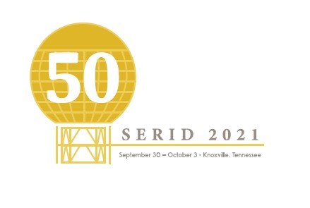
CALL FOR INTERPRETERS
Invitation: The 2021 Southeast Regional Institute on Deafness (SERID) will be held at the Hilton Downtown Knoxville in Knoxville, TN September 30-October 4. SERID focuses on the educational and professional development of individuals who work with consumers who are Deaf, Deaf Blind, Hard of Hearing, and late- deafened. The conference is designed to allow participants to explore cutting-edge principles, strategies, and tools that will enable them to provide accessible services to those they serve. SERID will consist of concurrent sessions, plenary sessions, pre-conference workshops, and exhibits.
REQUIREMENTS FOR INTERPRETERS:
- Completed applications must be submitted by August 20,2021.
- Interpreters must hold current RID certification or NAD certification Levels IV or V.
- Resume of prior conference work
Please send Completed Application (next page), Resume, and Relevant Certifications to:
Lisa Rimmell
info@serid.org
OR
P.O. Box 3
Knoxville, TN 37901

Please complete the following:
Name:

Address:

City: | State: |  | Zip:
Email:

Phone: Voice/Text |  | VP:

Please indicate your strengths below based on a 1-5 scale
(5 being the highest and 1 being the lowest. You may have more than one strength, please indicate all)
Interpreting | 1 2 3 4 5
Sign to Voice | 1 2 3 4 5
Voice to Sign | 1 2 3 4 5
Transliteration | 1 2 3 4 5
Deaf Blind Interpreting | 1 2 3 4 5
Deaf Blind: TRACKING | 1 2 3 4 5
Deaf Blind: TACTILE | 1 2 3 4 5
Deaf Blind: CLOSE VISION | 1 2 3 4 5
Deaf Blind: HAPTICS | 1 2 3 4 5
Deaf Blind: PRO-TACTILE | 1 2 3 4 5

Please indicate your availability:
Wednesday, September 29
Thursday, September 30
Friday, October 1
Saturday, October 2
Sunday, October 3

