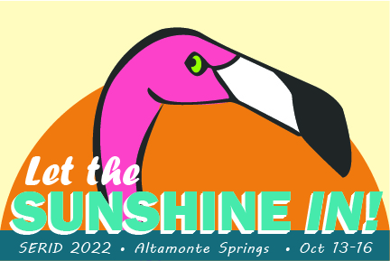
SERID 2022
CALL FOR EXHIBITORS

Invitation to exhibition

The 2022 Southeast Regional Institute on Deafness (SERID) will be held in person at the Hilton Orlando/Altamonte Springs in Altamonte Springs, FL from Oct 13-16. SERID supports training in vocational rehabilitation, education and mental health for professionals who assist Deaf, Hard of Hearing and DeafBlind. Working together, we learn, share and network new and creative ways to support individuals who are Deaf, Hard of Hearing and DeafBlind.
SERID is a non-profit organization. We invite your organization to become an exhibitor. Please review the exhibition information provided here and support SERID today.

EXHIBITION: GENERAL INFORMATION

- SERID is offering in-person exhibition opportunities.
- All sponsorships, exhibitions, and events will be held onsite at the Hilton hotel.
- Exhibitions begin on Thursday, October 13, at 10:00 AM and end on Saturday, Oct 15, at 5:00 PM.
- Exhibitors will be responsible for the set up and break down of their materials.

Would you like to become an exhibitor? Please see the information below.

EXHIBITION LEVELS

LEVEL | PRICE
Standard Exhibition booth | $250
Non-profit organizations | $200
Deaf artisans/Deaf owned businesses | $175

If you have a video advertisement of your organization that you would like played on monitors during the conference, you may pay an additional $100. Please make sure that your video has closed captioning.

HOW TO BECOME AN EXHIBITOR

If you would like to donate funds at any level or set up an exhibition, please send an email to the SERID contact person listed below. Include the following information:

- Organization name
- Type of organization
- Dates of exhibition desired
- Point of contact

Once we receive your email, we will contact you with more details on location and exhibition,

Send all exhibitor inquiries to Drew Wann at info@serid.org. We encourage you to complete and send this information no later than August 15.

THANKS FOR ALL YOUR SUPPORT!

