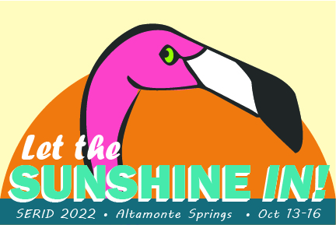
SERID 2022
CALL FOR SPONSORS AND EXHIBITORS

Invitation to support

The 2022 Southeast Regional Institute on Deafness (SERID) will be held in person at the Hilton Orlando/Altamonte Springs in Altamonte Springs, FL from Oct 13-16. SERID supports training in vocational rehabilitation, education and mental health for professionals who assist Deaf, Hard of Hearing and DeafBlind. Working together, we learn, share and network new and creative ways to support individuals who are Deaf, Hard of Hearing and DeafBlind.
SERID is a non-profit organization. We invite your support. Please review the sponsorship information provided here and support SERID today.

SPONSORSHIP: GENERAL INFORMATION

- SERID is offering five levels of sponsorship and exhibition.
- SERID also accepts donations outside of the set sponsorship levels.
- All sponsorships, exhibitions, and events will be held onsite at the Hilton hotel.
- Exhibitors will be responsible for the set up and break down of their materials.

Want to become a sponsor or exhibitor? Please see the sponsorship levels below.

SPONSORSHIP LEVELS

LEVEL | BENEFITS
Diamond: $10,000 | Full page advertisement in program book  Exhibition booth  Three complimentary conference registrations  Opportunity to speak for five minutes during general session and ten minutes during at banquet  Opportunity to display a video advertisement  Complimentary 1 hour workshop to your staff on any aspect of VR services  Naming rights to a conference room (“sponsored by”)
Platinum: $5,000 | Half page advertisement in program book  Exhibition booth  Two complimentary conference registrations  Opportunity to speak for five minutes during general session  Opportunity to display a video advertisement  Complimentary 1 hour workshop to your staff on any aspect of VR services
Gold: $1,000 | Quarter page advertisement in program book  Exhibition booth  One complimentary conference registrations  Opportunity to display a video advertisement
Silver: $500 | Business card size advertisement in program book  Exhibition booth
Non-profit organizations: $300 | Business card size advertisement in program book  Exhibition booth
Friends of SERID: $250 | Business card size advertisement in program book
Deaf artisans/entrepreneurs: $250 | Business card size advertisement in program book  Exhibition booth
Note: In addition to the levels detailed here, SERID will accept contributions of any amount. We welcome whatever funds you are able to donate to the event.

HOW TO BECOME A SPONSOR OR EXHIBITOR

If you would like to donate funds at any level or set up an exhibition, please send an email to the SERID contact person listed below. Include the following information:

- Organization Name
- Point of Contact
- Level of Sponsorship/Contribution/Exhibition
- Communication Access Needs (e.g. sign language interpreter)

Once we receive your email, we will contact you with more details on advertisements, payment, and exhibition.

Send all sponsorship and exhibitor inquiries to Drew Wann at info@serid.org. We encourage you to complete and send this information no later than August 15.

THANKS FOR ALL YOUR SUPPORT!

