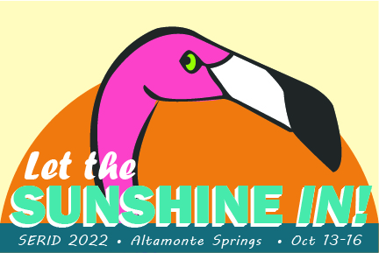
SERID 2022
CALL FOR INTERPRETERS

WE WANT YOU!

The 2022 Southeast Regional Institute on Deafness (SERID) will be held in person at the Hilton Orlando/Altamonte Springs in Altamonte Springs, FL from Oct 12-16. SERID supports working with professionals who seek vocational rehabilitation training in Deaf, Hard of Hearing and DeafBlind. Working together, we learn, share and network new and creative ways to support individuals who are Deaf, Hard of Hearing and DeafBlind.

GENERAL INFORMATION

- Interpreters must hold current RID or BEI certification.
- Interpreters must provide a resume showing conference experience.
- Interpreters must provide proof of certification.
- The deadline for submitting an application is August 15, 2022.
- There is a limited need for interpreters the night of October 12 for the SERID Board meeting, and the morning of October 16 for the farewell breakfast. October 13-15 there will be a need for more as these are the days of actual concurrent workshop sessions.
- SERID is committed to providing a healthy environment for learning and networking. We encourage all attendees to follow CDC recommendations, including:
- Practicing social distancing
- Wearing masks in enclosed spaces
- Frequently washing and sanitizing hands
We will monitor the situation and make additional recommendations as needed.

Interested in interpreting at SERID? Please fill out the form below.

INTERPRETER APPLICATION

Name
Address
Email
Phone (cell)
Available from Wednesday, Oct 12 - Sunday, Oct 16 (please list all possible dates)

SELF-RATING SCALE

Please rate yourself from 1-5 on the following skills (5 being the highest and 1 being the lowest).
Skill | Rating (1-5)
General Interpreting
Sign to Voice
Voice to Sign
Transliteration
DeafBlind Interpreting
DeafBlind Interpreting: Tracking
DeafBlind Interpreting: Tactile
DeafBlind Interpreting: Close Vision
DeafBlind Interpreting: Pro-Tactile
DeafBlind Interpreting: Haptics

Please send this form, proof of certification, and a resume to Daniel LeMay at SERIDconfinterp2022@gmail.com. We encourage you to send all information and applications by August 15. Thank you for joining us.

