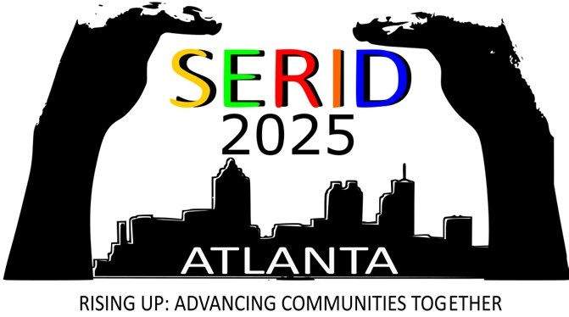

SERID Conference 2025, P.O. Box 34, Clarkston, GA, 30021, [www.serid.org](http://www.serid.org), [info@serid.org](mailto:info@serid.org)

**Sponsorships**

Name of your Company or Organization: ________________________________________________

Address: _____________________________________________________________________________

City/State/Zip Code: ___________________________________________________________________

Position: __________________________ Email: ____________________________

Text: _____________________________ Videophone: ______________________

**_______ Diamond Level - $10,000 and Up**

* Digital recognition as a partner during conference and on the app
* Five-minute opportunity to address the conference participants or 5-minute video to present during the banquet
* One exhibit space with two chairs
* Three conference registrations

**_______ Platinum Level - $7,500**

* Digital recognition as a partner during conference and on the app
* Five-minute opportunity to address the conference participants or a five-minute video for one main event (opening ceremony, banquet or closing keynote)
* One exhibit space with two chairs
* Two conference registrations

**_______ Gold Level - $5,000**

* Digital recognition as a partner during conference and on the app
* Two-minute address the conference participants at opening or closing keynote
* One exhibit space with two chairs
* One conference registration

**_______ Silver Level - $2,500**

* Digital recognition during conference and on the app
* One exhibit space with two chairs
* One conference registration

**_______ Bronze Level - $1,000**

* Digital recognition during conference and on the app
* One exhibit space with two chairs

We hope you will take this opportunity to provide support as well as provide great visibility for your organization during the conference.

Payment shall be provided to the SERID Conference 2025 by October 10, 2025.

PAYMENTS can be mailed to:

SERID Conference 2025

ATTN: Jack Johnson, Treasurer

P.O.Box 34

Clarkston, GA 30021

For questions or more information, contact Russell Fleming at [russell.fleming@gvs.ga.gov](mailto:russell.fleming@gvs.ga.gov)

Thank You!

Russell Fleming

Planning Committee

SERID 2025 Atlanta Conference

[russell.fleming@gvs.ga.gov](mailto:russell.fleming@gvs.ga.gov)

VP: 706-622-4421