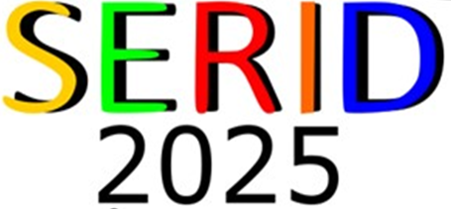
NOVEMBER 6th-9th, 2025
Rising Up: Advancing Communities Together

SERID 2025 Call for Nominations
SERID annually recognizes achievement within its service profiles. The 2025 focus is on these specific service groups residing within the Deaf, Hard of Hearing, and Deaf-Blind communities.
SERID is seeking nominations for outstanding service to individual(s) in the categories listed below. Winners will be announced on the evening of Saturday, November 8th, during the Awards Banquet.
Help us bring attention to the excellence, initiative, hard work, and innovation of your colleagues and recognition from their peers by sending a nomination letter that includes the following:
- Award Category
- Name of nominee with contact information, including phone, employer, and title
- Explanation providing support for nomination (200-500 words)
- Biography of the nominee (150 words)
- Your name, contact information, and relationship to the nominee
- You may also include additional letters of support from others who wish to nominate and honor an individual or employer.

The deadline to submit nominations is August 8, 2025.
Please email nomination letters to: kelly.stockdale@avitapartners.org.
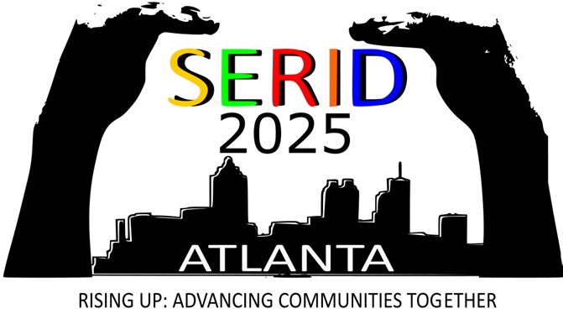

NOVEMBER 6TH – 9TH, 2025
AWARD CATEGORIES:
Distinguished Service Award: This award is presented to an individual who has demonstrated outstanding community leadership, personal achievement, or contributions to persons who are Deaf, Hard of Hearing, or Deaf-Blind
Outstanding Deaf/ Hard of Hearing Citizen: This award is presented to a Deaf, Hard of Hearing, or Deaf-Blind individual who has exhibited outstanding leadership within the Deaf, Hard of Hearing, or Deaf-Blind community
Outstanding Educator of the Year: This award is presented to an individual who exemplifies the highest standard of the educational profession by demonstrating an extraordinary commitment to educational excellence for the education excellence, learning, and welfare of persons who are Deaf, Hard of Hearing, or Deaf-Blind
Outstanding Employer of the Year: This award is presented to an employer in recognition of outstanding efforts in recruiting and hiring persons who are Deaf, Hard of Hearing, or Deaf-Blind
Marie E. Griffin Interpreter of the Year: This award is presented to an interpreter who has demonstrated outstanding community leadership or contributions to the field of interpreting or to the Deaf, Hard of Hearing, or Deaf-Blind community through higher efforts in making communication more accessible and increasing awareness for the need for better communication.
William E. Woodrick Case of the Year: This award is presented in recognition of unique and/or outstanding efforts in the rehabilitation of a person who is Deaf, Hard of Hearing, or Deaf-Blind employment resulting in successful employment. Please include this information in the narrative:
- Identifying Date 4. Solutions of Problems
- Background Information 5. Placement
- Identification of Problems 6. Summary and Justification for Selection of this Case

