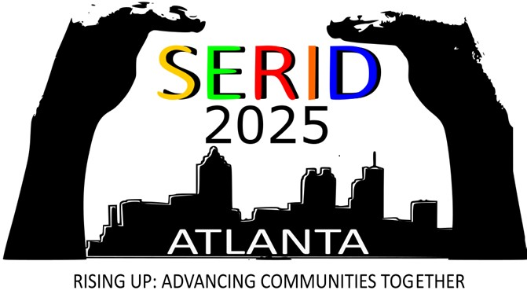
Board Meeting Agenda
SERID Conference 2025

Wednesday, November 05, 2025

SERID Executive Board Meeting
5:00 PM – 8:00 PM
Thursday, November 06, 2025

State Coordinators for the Deaf Meeting
9:00 AM – 4:00 PM
This meeting is only for State Coordinators for the Deaf.

State Coordinators for the Deaf Blind Meeting
9:00 AM – 4:00 PM
This meeting is only State Coordinators of the DeafBlind.

