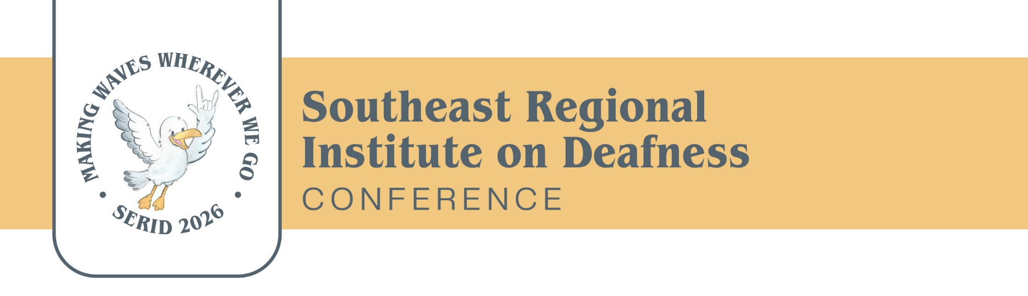

2026 SERID Call for Speakers
Call for Proposals: Southeast Regional Institute on Deafness (SERID) 2026
📅 Conference Dates: October 25-30, 2026
📍 Location: Golden Nugget, Biloxi, MS
🎭 Theme: Making Waves Wherever We Go
📌 Proposal Deadline: June 1, 2026
The Southeast Regional Institute on Deafness (SERID) is excited to announce the Call for Proposals for our 2026 conference! This year’s theme, "Making Waves Wherever We Go," calls on us to motivate, empower, and unite our diverse communities—including the Deaf, Deaf-Blind, Hard-of-Hearing and Late-Deafened populations. Together, we will explore how we can foster inclusion, advance accessibility, and create lasting change for all individuals within these communities.
We invite speakers, researchers, educators, and advocates with a passion for creating positive impact and inspiring social change to submit proposals that contribute to this powerful movement. Whether you’re working to advance access, bridge gaps, or build stronger support networks, we want to hear your ideas!
Who Should Submit a Proposal?
- Educators and Teachers of the Deaf and/or Deaf-Blind
- Researchers and Scholars
- Service Providers
- Community Leaders and Advocates
- Deaf, Deaf-Blind, and Hard-of-Hearing Individuals with Lived Experience
What We’re Looking For: We seek dynamic proposals that explore how we can thrive to create inclusive, accessible, and thriving communities for the Deaf, Deaf-Blind, and Hard-of-Hearing individuals. We encourage you to submit sessions that cover topics such as:
- Advocacy and Empowerment for the Deaf-Blind Community
- Intersectionality in the Deaf and Deaf-Blind Communities
- Inclusive Education Models for Deaf, Deaf-Blind, and Hard-of-Hearing Students
- Access to Technology and Communication Tools for the Deaf-Blind
- Mental Health and Wellness Across the Deaf, Deaf-Blind, and Hard-of-Hearing Populations
- Advancing Accessibility and Policy Change
- Leadership Development in the Deaf and Deaf-Blind Communities
- Building Bridges Between Deaf, Deaf-Blind, and Mainstream Communities
- Inclusive Social Justice and Equality for All
- Innovative Approaches to Early Intervention and Language Development
Types of Sessions We’re Looking For:
- Interactive Workshops
- Panel Discussions
- Research Presentations
- Roundtable Conversations
- Keynote Talks
- Skill-Building Sessions
- Networking Events
Submission Guidelines:
- Deadline: JUNE 1, 2026
- Submission Link- https://serid.org/2026-serid-conference/call-for-presenters/
- Proposals must include a session description (250-500 words) with three learning objectives, speaker bios, and any specific technical requirements.
- Submissions will be reviewed based on originality, relevance to the theme, and potential impact on the community.
- Each Presenter may submit up to two proposals.
Why Present at SERID 2026?
- Make a Difference: Share your insights and work that will inspire change and advance the Deaf, Deaf-Blind, and Hard-of-Hearing communities.
- Build Connections: Network with leaders, advocates, educators, and other stakeholders who share your passion for inclusion and empowerment.
- Engage with Diverse Audiences: Present your ideas to a wide range of professionals, community members, and individuals with lived experience.
- Advance the Conversation: Contribute to critical conversations about accessibility, empowerment, and equality for the Deaf, Deaf-Blind, and Hard-of-Hearing individuals.
Together, we can build a more inclusive, accessible, and supportive communities for all individuals. Join us in this movement toward lasting change.
Submit your proposal today! Don’t miss out on the opportunity to make an impact at SERID 2026!
For more information and to submit your proposal, visit LINK TO WEBSITE

📣 Spread the Word!
Know an inspiring speaker or someone who should present? Please share this CFP with:
- Colleagues who have delivered impactful workshops.
- Professionals who should share their expertise.
- Anyone who can recommend great presenters!
We can’t wait to see your ideas and collaborate toward advancing communities!

The Southeast Regional Institute on Deafness (SERID) is committed to creating a welcoming and inclusive environment for Deaf, Deaf-Blind, Hard-of-Hearing and Late Deafened individuals, and we celebrate the diversity within these communities.

