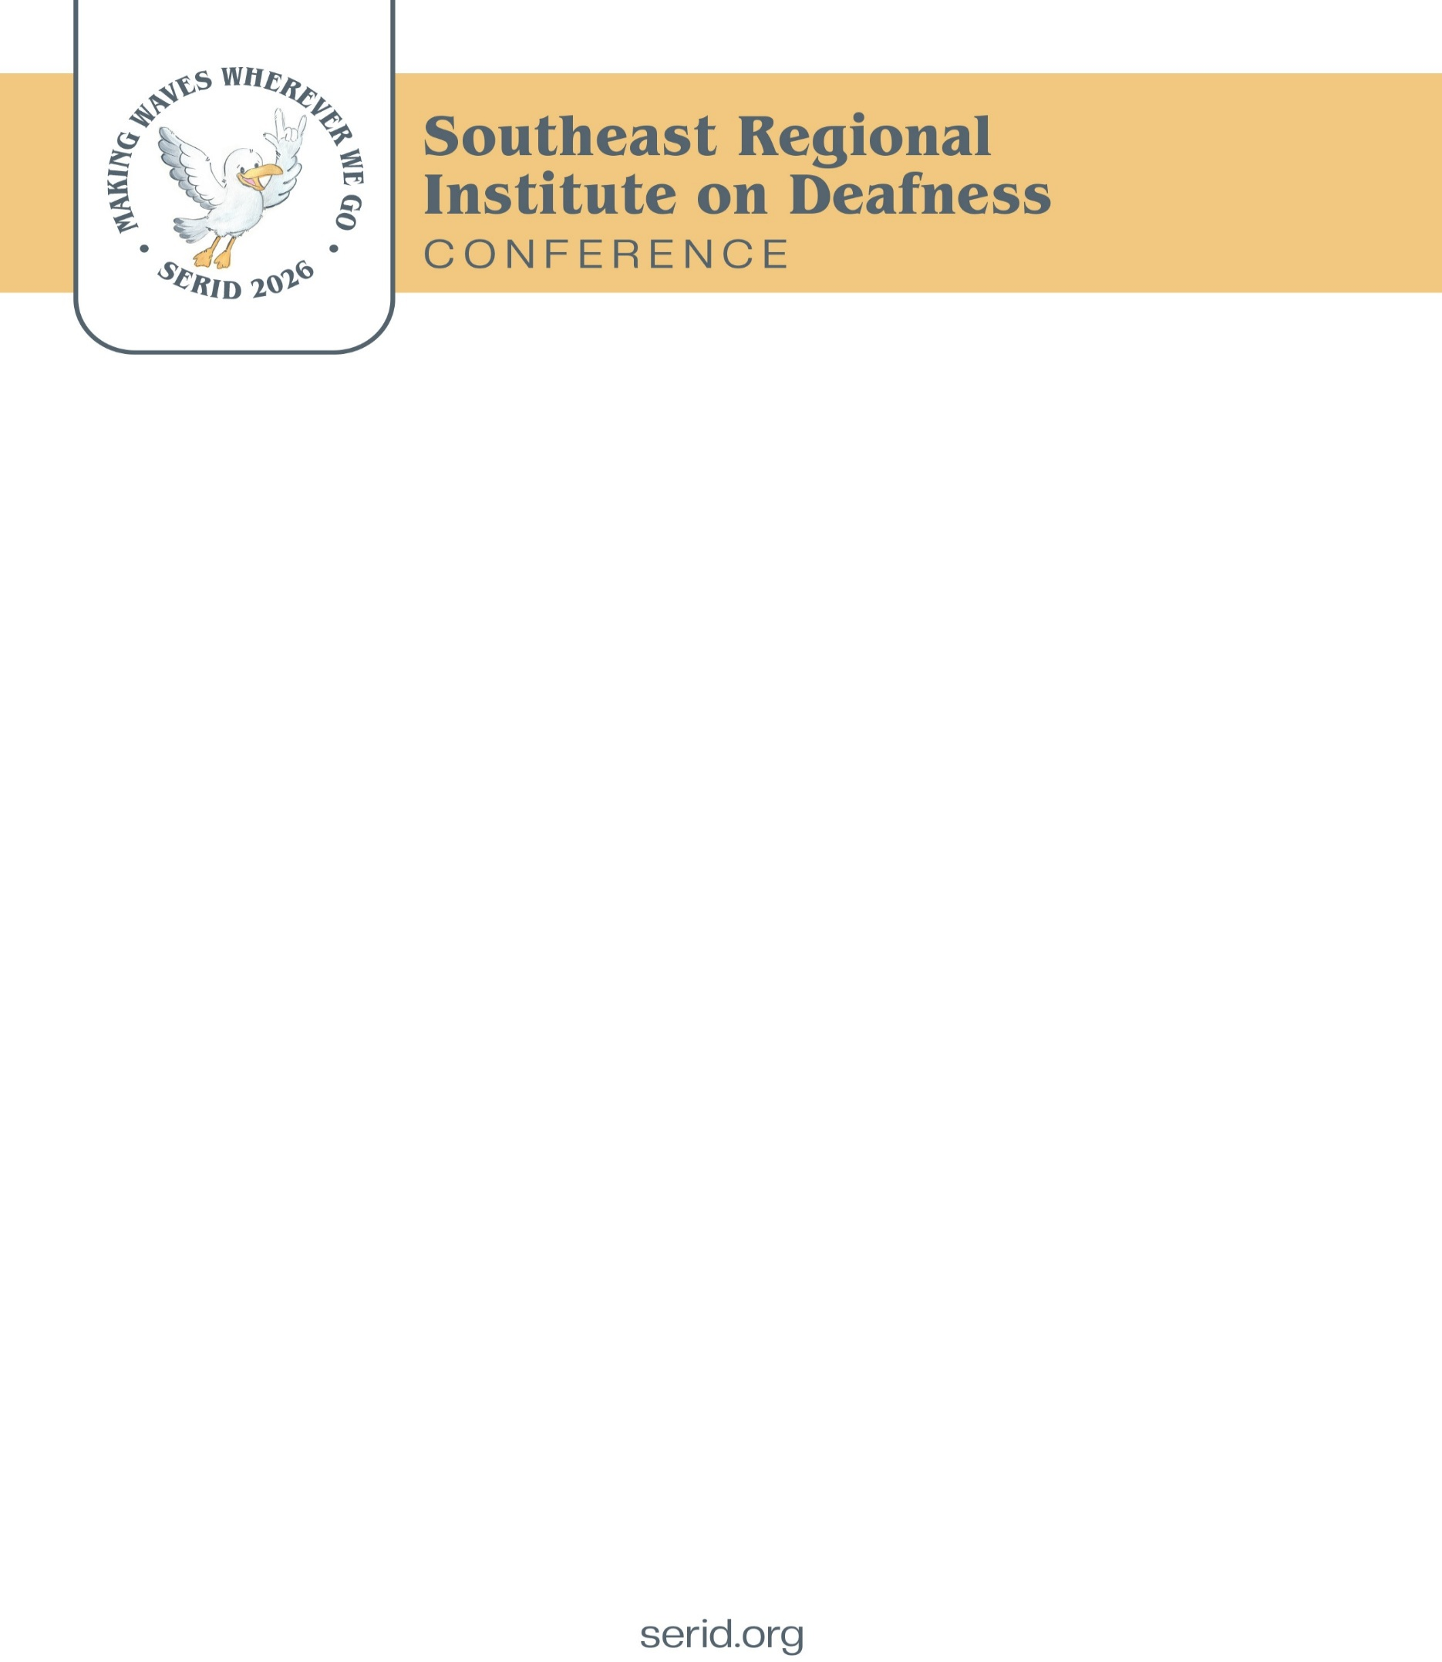

SERID 2026 Registration Form
October 27-30, 2026
Name: |  | Email:
Name on badge:
Organization/Agency:
Address for Correspondence:
City: |  | State: Zip Code:
Phone Number: ________________ ☐ Voice ☐ Text ☐ VP ☐ Other: _________ Fax: ________________
Emergency Contact Name: | Emergency Phone Number: |  | Choose one:
 |  |  | ☐ Voice ☐ Text ☐ VP
*This individual may be contacted by SERID, Inc. in case of emergency during the conference
Registration Options
Conference Registration Categories  (Registration Includes: meals, workshops, exhibit hall and conference materials) |  |  | Amount
Early Full Registration | Postmarked on or before June 1, 2026 | $400
Full Registration | Postmarked on or before August 1, 2026 | $450
Late/On-Site Registration | Postmarked o or after August 2, 2026  (Does not include meals) | $475
Pre-Conference Optional Workshops take place Oct. 26, 2026
IL Deaf/Blind Service provision in MS - EMERGE Center -  (Other workshop TBD) | This is in addition to the standard conference registration.  *Register as late as the day of the event | $150 per workshop
Total Registration Due:
Continuing Education Units/Credits Desired: (check all that apply)
☐ CRCC ☐ RID CEUs ☐ General CEUs
Planning Note: The Planning Committee is researching other CEUs options that may be offered.
Payment Options:
Credit Card Payments:  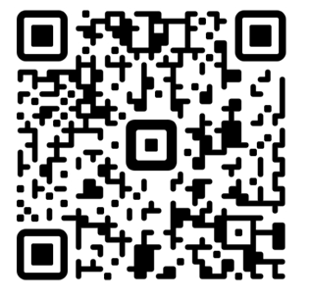  QR Code Link: | Mail Check or Money Order:  - Complete and print this form  - Make check/money order payable to: SERID 2026 Conference  - Mail to: SERID 2026 Conference  Attn: Mary Hudgens/MDRS  P.O. Box 1698  Jackson, MS 39215-1698  Email:  - Complete and email this form to: serid2026@gmail.com  - Pay via the QR Code  Note: A committee member will respond via email with confirmation within seven (7) days of receiving a complete registration and payment. If you do not receive a confirmation email within that timeframe, please contact us at serid2026@gmail.com
Refund Requests and Charges:
- Refund requests must be submitted in writing to serid2026@gmail.com by October 12, 2026. Refund requests will be reviewed and be considered on a case-by-case basis minus a $50 cancellation fee.
- Returned checks will be subject to a $50 administrative fee.
Requests for Accommodation:
- Interpreting: ☐ ASL ☐ Signed English ☐ Oral
- Deaf-Blind: ☐ Tactile ☐ SSP ☐ Close Vision ☐ Room Familiarization
- Assistive Listening Devices (ALD): ☐
- Specific Diet: ☐ Vegetarian ☐ Diabetic ☐ Other (specify)
- Other Accommodation Requested (Please Specify): ___________________________________________________________________________________________
- Please list any comments, concerns, or other information you have or feel is important for SERID:______________________________________________________________________________
NOTE: Accommodations requested after September 1, 2026, cannot be guaranteed.
DISCLAIMER:
Upon completing the registration process, you give SERID Inc. permission to use pictures of you taken during the conference, your name, and/or your likeness to be used at the discretion of SERID for advertisement and other administrative purposes.

Visit the website or Facebook page:
2026 SERID Conference – SERID Southeast Regional Institute on Deafness | Facebook

For MDRS Only:
Registration/Payment  Date Rec’d: _______________________  Amount/Method: __________________  Date Cleared: _____________________ | Refund Request  Date Rec’d: ________________  Fiscal/Form Notified: ☐ Yes  Date/Amt Sent: ____________ | Form Rec’d for Name Tag  Date Entered in Database:  ____________________________  Name tag made: ☐ Yes  Copy to Accom. Team: ☐ Yes

