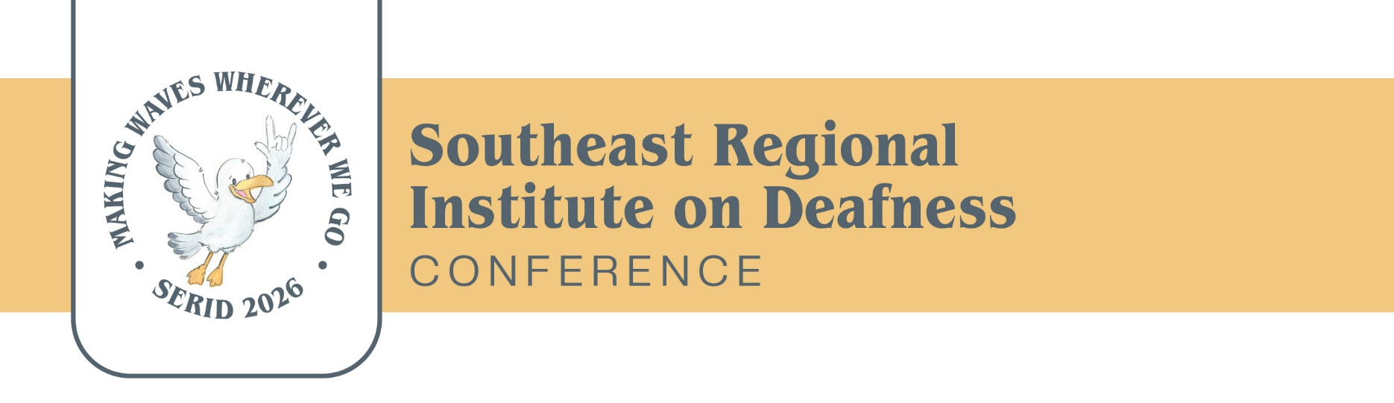
SERID 2026 Exhibitor Application
October 27-30, 2026

Organization Name: _________________________________________________________
Mailing Address: _____________________________________________________________
Contact Person/Position:______________________________________________________
Telephone: __________________________ Video Phone: __________________________
Text: ________________________________ Email: _________________________________
Brief Description of Products/Services:
______________________________________________________________________________
______________________________________________________________________________
Names of Exhibit Participants:
- ________________________________________________________________________
- ________________________________________________________________________
- ________________________________________________________________________
- ________________________________________________________________________
Electricity Needs: (Check One)
☐ Yes
☐ No

Exhibit Rate: (Check One)
☐ $600 – Corporate
☐ $500 – Government / Education / Non-Profit

Payment Options:
Pay Online: Scan the QR Code:
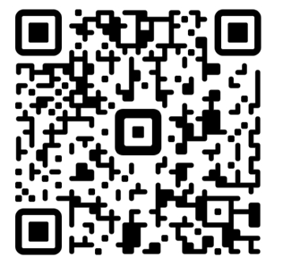
Checks Payable To:
SERID Conference 2026
Attn: Mary Hudgens/MDRS
P.O. Box 1698
Jackson, MS 39215-1698

Important Dates & Policies:
- Submission Deadline: October 10, 2026
- Cancellation Deadline: October 1, 2026 (must be submitted in writing via mail or email to serid2026@gmail.com)
- Exhibitors are encouraged to contribute a door prize valued around $50.

Exhibit Space Includes:
One (1) six-foot table and two (2) chairs per exhibit space

Signature: ______________________________________ Date: _______________________
2026 SERID Conference – SERID Southeast Regional Institute on Deafness | Facebook

