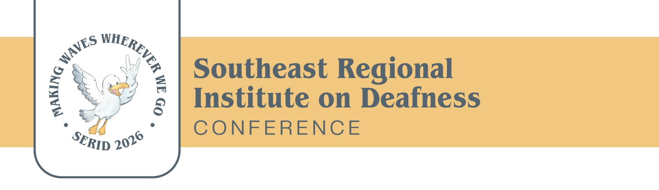

SERID 2026 Conference Sponsorship Form
October 27-30, 2026

Organization Name: _________________________________________________________
Mailing Address:______________________________________________________________
Contact Person/Position:______________________________________________________
Telephone: __________________________ Video Phone: __________________________
Text: ________________________________ Email: _________________________________
Sponsorship Levels
_____ Diamond Level – $10,000+
• Digital recognition during conference and on the app
• Five-minute address or video presentation during banquet
• One exhibit space (includes two chairs)
• Three conference registrations
_____ Platinum Level – $7,500
• Digital recognition during conference and on the app
• Five-minute address or video during a main event (opening, banquet, or closing keynote)
• One exhibit space (includes two chairs)
• Two conference registrations
_____ Gold Level – $5,000
• Digital recognition during conference and on the app
• Two-minute address at opening or closing keynote
• One exhibit space (includes two chairs)
• One conference registration
_____ Silver Level – $2,500
• Digital recognition during conference and on the app
• One exhibit space (includes two chairs)
• One conference registration
_____ Bronze Level – $1,000
• Digital recognition during conference and on the app
• One exhibit space (includes two chairs)
_____ Break Sponsor – $500
• Includes signage recognition during the sponsored food break
• Digital recognition during conference and on the app

Payment Options:

Pay Online:
Scan the QR Code
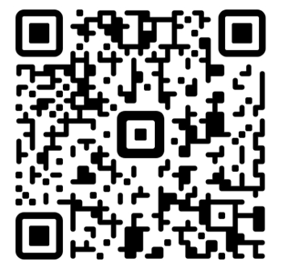
Checks Payable To:
SERID Conference 2026
Attn: Mary Hudgens / MDRS
P.O. Box 1698
Jackson, MS 39215-1698
serid2026@gmail.com
Payment Deadline: October 10, 2026
For More Information, Contact:
Kaye Carr
Planning Committee, SERID 2026 Mississippi Conference
kcarr@mdrs.ms.gov

Signature: ______________________________________ Date: _______________________

We appreciate your support and the opportunity to highlight your organization during the conference!

Visit the website at 2026 SERID Conference – SERID
Southeast Regional Institute on Deafness | Facebook

