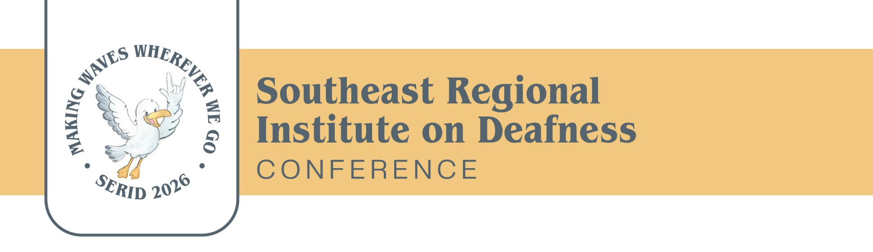

SERID 2026 – Call for Nominations
SERID proudly recognizes excellence each year across its service areas. For 2026, we are highlighting outstanding contributions from individuals and organizations serving the Deaf, Hard of Hearing, and Deaf-Blind communities.
We invite you to submit nominations for exceptional service in the award categories listed below. Award recipients will be announced on Wednesday, October 28th, during the SERID Awards Dinner.
Help us honor the excellence, initiative, dedication, and innovation of your colleagues by submitting a nomination letter that includes:
- Award category
- Nominee’s name and contact information (phone, employer, title)
- A nomination statement (200–500 words) describing why the nominee deserves recognition
- A brief biography of the nominee (150 words)
- Your name, contact information, and relationship to the nominee
- Optional: Additional letters of support from others who wish to recognize the nominee
Nomination Deadline: August 15, 2026 Please email all nomination materials to kcarr@mdrs.ms.gov

SERID 2026 Award Categories
October 27-30,2026

Marcia Kolvitz Distinguished Service Award
Presented to an individual who has demonstrated exceptional community leadership, personal achievement, or significant contributions to people who are Deaf, Hard of Hearing, or Deaf-Blind.

Outstanding Deaf/Hard of Hearing Citizen
Presented to a Deaf, Hard of Hearing, or Deaf-Blind individual who has shown exemplary leadership within their community.

Outstanding Educator of the Year
Presented to an educator who upholds the highest standards of the profession and demonstrates extraordinary commitment to the learning, growth, and well-being of individuals who are Deaf, Hard of Hearing, or Deaf-Blind.

Outstanding Employer of the Year
Presented to an employer who has shown exceptional dedication to recruiting, hiring, and supporting employees who are Deaf, Hard of Hearing, or Deaf-Blind.

Marie E. Griffin Interpreter of the Year
Presented to an interpreter who has demonstrated outstanding leadership, professional achievement, and meaningful contributions to the interpreting field or to the Deaf, Hard of Hearing, or Deaf-Blind communities—especially through efforts that improve communication access and awareness.

William E. Woodrick Case of the Year
Presented in recognition of unique and/or exceptional efforts in the vocational rehabilitation of a Deaf, Hard of Hearing, or Deaf-Blind individual resulting in successful employment. Please include the following in the narrative:
- Identifying date
- Background information
- Identification of problems
- Solutions to problems
- Placement
- Summary and justification for selecting this case

